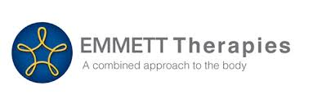

 Dear Health Practitioner or interested person.

Would you like another “STRING TO YOUR BOW?” Coming back to New Zealand soon – the wonderful modality known as **The Emmett Technique**.

**“Have you ever wanted a way to quickly relieve muscular pain for your patients?  Do your patients suffer from unbearable pain of Arthritis, muscular pain or headaches?  Emmett Technique is a unique body therapy technique created by Ross Emmett.  It is so effective and acceptable that medical practitioners and lay therapists alike are requesting to learn it.  Treatments can be done fully clothed and incorporate a gentle physical release of muscle groups while using a verbal approach to create attitude change.**

**Ross Emmett's "Emmett Technique” has been growing in popularity worldwide since he first started teaching the technique in 1999. The technique has wide appeal: not only is it being enthusiastically picked up by Bowen therapists, massage therapists and medical staff, but we are seeing an increasing number of exercise professionals such as Pilates Instructors and Personal Trainers eager to learn and use this remarkable technique. It is a technique which can be used in a truly complementary way with any other body work or exercise system offering a valuable addition to anyone working to ease pain and discomfort or restore musculoskeletal function to others. That's how Ross encourages all of us to use his work, though it is a powerful standalone technique in its own right”.**

**For more background information and a bio - -  [https://rossemmett.com.au/about/ross-emmett](https://rossemmett.com.au/about/ross-emmett" \t "_blank)**

The results of a treatment are often immediate and will enable you to help clients, friends and family for conditions such as  - -

Neck and shoulder restriction

Migraines and headaches

abdominal cramps and bowel discomfort

Persistent heel and foot pain

Dizziness

Balance problems

Back and hip discomfort

Knee and ankle restrictions

Fluid retention…. And much, much more…….

The Emmett Technique is a complete therapy on its own, but has the ability to work in conjunction to complement other treatments. It often allows other therapies to work more efficiently.

Do look at the website for further information [http:/www.rossemmett.com.au](http://www.rossemmett.com.au)    To register and pay online go to this web address <https://www.emmett-technique-hq.com/course-dates> and scroll down to Ross’s Napier course dates and click on to register from there.

– lots of info there and also Facebook and Twitter.

One of the rare times Ross will be instructing the basic foundation modules of the Emmett technique here in NZ.

 WHEN IS ROSS COMING TO NEW ZEALAND?  He is coming to Napier in March 2018.

**Come and meet the man behind the Technique!**

**NAPIER DATES of the COURSE and COSTS**

Module 1&2 – Sat 10th/ Sun 11th March 2018                      Course Cost  $590.00

Understand that each module completed is reviewed the next day before the new module is taught.  This has the advantage of ensuring competence and therefore effectiveness as you go out to practice.  This explains the ‘double up’.  Manuals are included in the price. 

**This is an exciting opportunity for you.  Don’t miss out as there are limited spaces available.**

 If you have other friends and family who would like to do this training do pass this on to them.  Also to any other physios, Occupational therapists, massage practitioners or any of the other myriad of complimentary Health Practitioners we are blessed with.  Emmett works in with other modalities really well.

**I look forward to hearing from you.  If you have further questions please ask.**

**With Warm Regards**

Karen Shields

*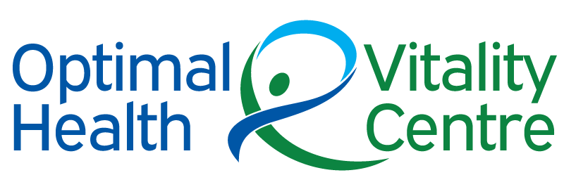*

**Karen Shields ND Natural Medicine Practitioner**

Phone: 06 843 7375 or 0272239460

Email: [info@optimalhealthcentre.co.nz](mailto:info@optimalhealthcentre.co.nz)

Website: [www.optimalhealthcentre.co.nz](http://www.optimalhealthcentre.co.nz/)

**LIKE US** on Facebook <https://www.facebook.com/Emmett-Technique-New-Zealand-497246447320918/>

Address: 224 Kennedy Road, Napier, Hawkes Bay 4110, New Zealand

**CONFIDENTIALITY**

The information in the above email message or messages (which includes any attachments) is confidential and maybe legally privileged. It is intended only for the use of the person or entity to which it is addressed. If you are not the addressee, any form of disclosure copying, modification, or distribution or any action taken or omitted in reliance on the information is unauthorised.

If you received this communication in error, please notify the sender immediately and delete it from your computer system network.