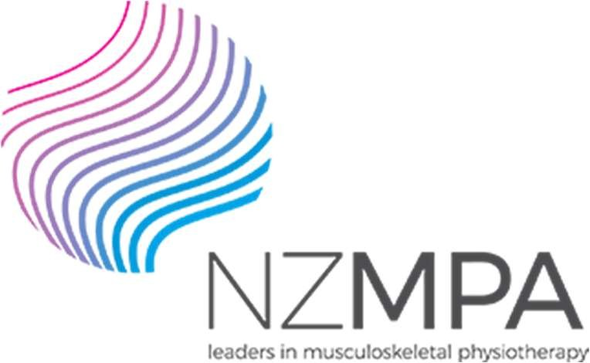 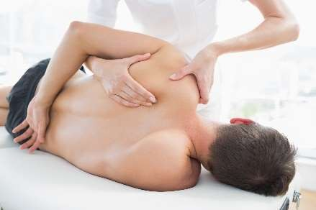

COMT 2020

Book online viz PNZ Events Directory

https://pnz.org.nz/pnz-events-directory The dates stated and schedule are provisional.

A minimum of 20 participants for each venue must be confirmed for course to take place, unless approved by NZMPA.

|  |  |  |  |  |
| --- | --- | --- | --- | --- |
| **Day One** | **Day Two** | **Course** | **Lead Tutor** | **Location** |
| **4-Jul** | **5-Jul** | **The Shoulder** | **Angela Cadogan** | **Auckland** |
| **5-Sep** | **n/a** | **HVT Review & Update** | **Duncan Reid** | **Auckland** |
| **17 Oct**  **7-Nov** | **18 Oct**  **8-Nov** | **Elbow, Wrist & Hand**  **Thoracic plus Review** | **Jill Caldwell**  **Duncan Reid** | **Auckland**  **Auckland** |
| **12-Sep 31-Oct**  **21-Nov** | **13-Sep 1-Nov**  **22-Nov** | **The Shoulder Elbow, Wrist & Hand**  **Thoracic plus Review** | **Angela Cadogan Jill Caldwell**  **Michael Monaghan** | **Wellington Wellington**  **Wellington** |
| **25-Jul**  **22-Aug** | **26-Jul**  **23-Aug** | **Low Back Pain Part 1 CANCELLED**  **Low Back Pain Part 2 CANCELLED** | **Steve White**  **Steve White** | **Christchurch**  **Christchurch** |
| **19-Sep** | **20-Sep** | **Hip & Knee**  **CANCELLED** | **Steve White Bronwyn Harman** | **Christchurch** |
| **17-Oct** | **18-Oct** | **Review plus Foot & Ankle**  **CANCELLED** | **Richard Ellis Michael Monaghan** | **Christchurch** |

* *Following Covid-19, NZMPA's courses are contingent on minimum numbers to make the courses viable. Participants are strongly encouraged to commit early to the course, so NZMPA can confirm course go- ahead early and at least two weeks before start date.*

NZMPA reserves the right to cancel a course should minimum numbers not be achieved.

* *Courses are subject to confirmation of venues, tutor flights and course numbers and changes to the Covid- 19 alert levels.*
* *Limited class participants: Minimum 20, up to a maximum 30 participants.*
* *Should a participant have to cancel due to Covid-19 or other reasons, NZMPA will look to offer a credit of the same value/confirmation placement towards your next course.*
* *Course participants are asked not to attend if they are feeling unwell or having symptoms of Covid-19 or been exposed to someone quarantining within 48 hours of course commencement.*
* *We refer you to the Covid-19.govt.nz website here for further details for gatherings under Alert Level 2 and Alert Level 1 (update due 8th June 2020)*

|  |  |  |
| --- | --- | --- |
| NZ**MPA** | 09 476 5353 | 0800 646 000 |
| w ww.nzmpa.org.nz | [admin@nzmpa.org.nz](mailto:admin@nzmpa.org.nz) |  |
| PO Box 35602 | Browns Bay | Auckland 0753 |